**GROUP 9**

**EXPERIMENT 3A**

**AIM:DATA PUBLISH IN THINGSPEAK USING DHT11 HUMIDITY SENSOR.**

**APPARATUS :**

1. NodeMCU( ESP8266 12E Board)
2. DHT11 Sensor
3. Breadboard
4. Jumper Wires
5. USB Cable

**BLOCK DIAGRAM:**

ThingSpeak IoT Cloud Server

**NodeMCU**

**DHT11 Sensor**

**Serial Monitor**

**Fig:1A**

* We are going to send humidity data to thingSpeak using DHT11, ESP8266 module.
* The NodeMCU ESP8266 Module 12E requests humidity readings from the DHT11 sensor;
* We have to  upload a program code to ESP8266 module; the uploaded program code on ESP8266 will accept data which will be forwarded to ThingSpeak platform via Wi-Fi connection.
* Then the collected data of humidity will be sent to the Serial Monitor.

**CODE:**

#include <WiFiClient.h>;

#include <ESP8266WiFi.h>;

#include <ThingSpeak.h>;

#include <DHTesp.h>;

#include <stdlib.h>;

#define DHTpin D3

const char ssid[] = "Codermaker"; // your network SSID (name)

const char pass[] = "babi1pal"; // your network password

DHTesp dht;

WiFiClient client;

unsigned long myChannelNumber =1387827;

const char * myWriteAPIKey = "2QVR2FRX38758GN3";

void setup()

{

Serial.begin(115200);

dht.setup(DHTpin,DHTesp::DHT11);

WiFi.begin(ssid,pass);

ThingSpeak.begin(client); // Initialize ThingSpeak

}

void loop()

{

float h = dht.getHumidity();

float t = dht.getTemperature();

Serial.println(h);

Serial.println(t);

ThingSpeak.setField(1, h);

ThingSpeak.setField(2, t);

ThingSpeak.writeFields(myChannelNumber, myWriteAPIKey);

delay(20000); // Wait 20 seconds to update the channel again

}

**OUTPUT:**

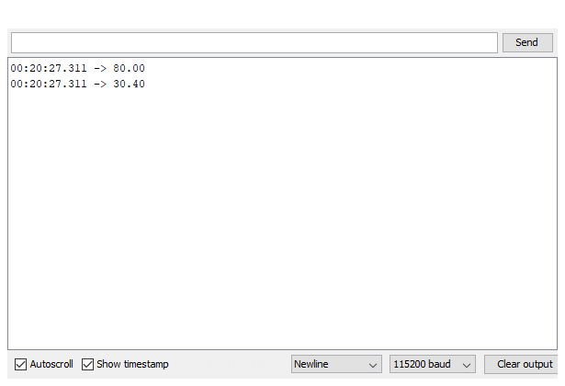

**Fig:1B**

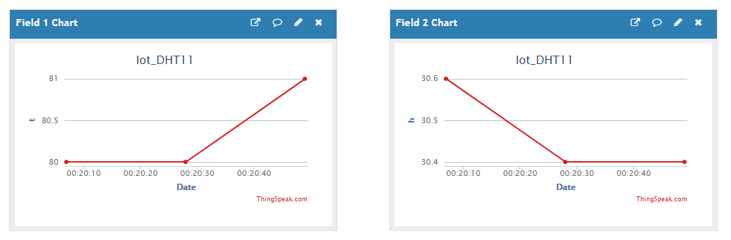

**Fig 1c**

**EXPERIMENT 3B**

**Objective:- Data Subscribe in ThingSpeak IOT cloud Server using DHT11 sensor.**

**Block Diagram:-**

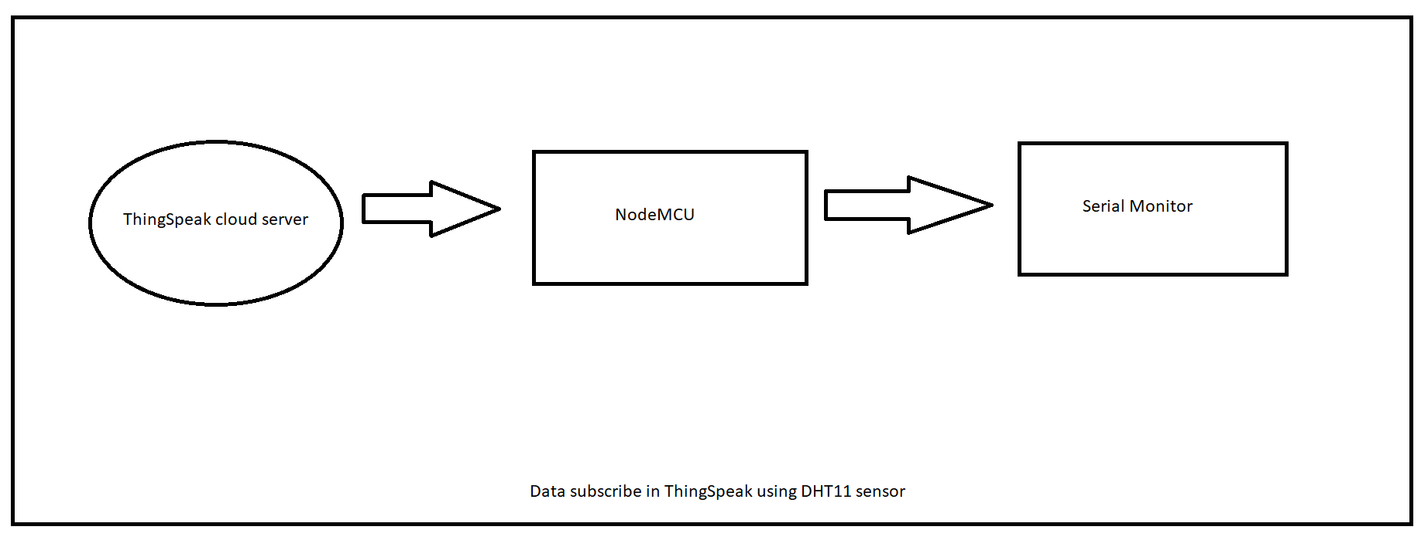

**Fig:2A**

**Explanation of the Block Diagram:-**

DHT11 sensor is connected to NodeMCU and NodeMCU is connected to the ThingSpeak cloud server using the Authentication key given during the registration . Data is subscribed from the ThingSpeak cloud using the http protocol.

**Apparatus:-**

* ESP8266 Wifi SOC
* DHT11 sensor
* Breadboard
* Connecting Wires
* ThingSpeak Cloud account.
* Wifi Internet Connection

**Programming:-**

#include <ESP8266WiFi.h>;

#include <WiFiClient.h>;

#include <ThingSpeak.h>;

const char* ssid = "Codermaker";

const char* password = "babi1pal";

WiFiClient client;

unsigned long myChannelNumber =1387827;

const char * myReadAPIKey ="0W4OJFXSKTZS4ZSZ";

int a,b;

void setup() {

Serial.begin(9600);

WiFi.begin(ssid, password);

ThingSpeak.begin(client);

}

void loop() {

a = ThingSpeak.readFloatField(myChannelNumber,1,myReadAPIKey);

Serial.println("Temperature");

Serial.println(a);

b = ThingSpeak.readFloatField(myChannelNumber,2,myReadAPIKey);

Serial.println("Humidity");

Serial.println(b);

Serial.println("+++++");

delay(1000);}

**Result:-**

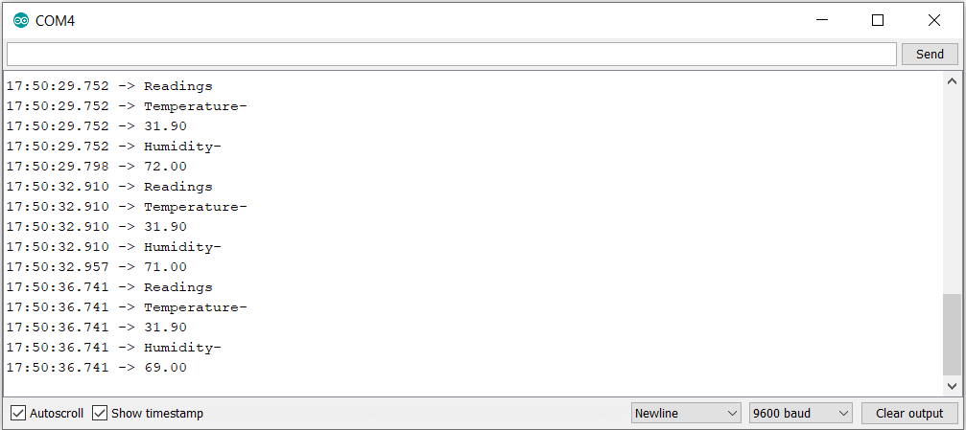

**FIG:2B**